FINANCE; BUYING A HOUSE ASSIGNMENT
STEP ONE: Determine how many bedrooms and bathrooms you would like in your house, condo or townhouse .Once you have determined that you write it down here.
- Two bathrooms
- Two bedrooms
STEP TWO: Find this type of house in your area or where you would like to live that is between $450,000 and $550,000. Take a screenshot of it and post it below here.
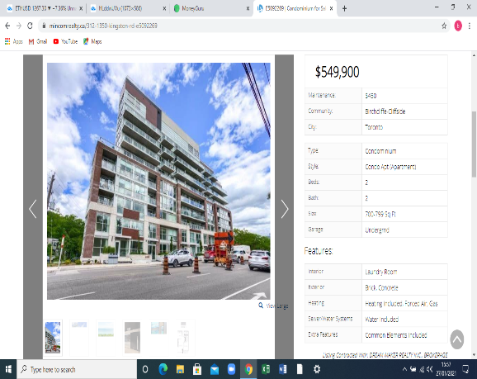
STEP THREE: List the cost of your house where it is located, how many bedrooms and bathrooms.
- COST -$549,900
- LOCATION –Toronto
- BEDROOMS- TWO
- BATHROOMS- TWO
STEP FOUR: Go to RBC Mortgage Calculator ,use the interest rate for their 5 year term ,monthly payments amortised over 25 years .Answer the following questions
- What is the monthly payment?
$2,387.35
- What is the total interest paid over 5 years?
$166,304.95
STEP FIVE: List in a chart how the payments will change if your payments are made, semi-monthly accelerated bi-weekly and accelerated weekly
PAYMENT FREQUENCY | PAYMENT AMOUNT | INTEREST COST FOR TERM
SEMI-MONTHLY | $596.84 | $27,579.91
ACCELERATED BI-WEEKLY | $1,193.68 | $55,159.82
ACCELERATED WEEKLY | $2,984.20 | $137,899.55

STEP SIX: Explain at least one reason for each of the payments methods instead of monthly .Use full sentence form for full marks.
- Semi Monthly-it reduces the principal balance early and increases the equity growth in your home
- Accelerated Bi-Weekly – It also reduces the principal balance and increases the home equity growth
- Accelerated weekly payment - The amount is withdrawn from the bank account every week but the payment amount is slightly more than a regular weekly mortgage payment
STEP 7: Suppose the mortgage for your house has an initial term of 5 years .The mortgage is renewed for another 5 years term at 1% higher than you are currently paying, with monthly payments.
- Use the amortisation table to determine the amount you still owe the bank after 5 years of payments .State this amount .This is the new amount that you are borrowing from the bank.

$605,701.01

- Determine your new monthly payments
$10,095.02

